**7.3**

**Metrics for Performance Evaluation**

Focus on the predictive capability of the model.

Don't focus on efficiency, scalability, etc.

Focus on accuracy.

**Confusion Matrix**

|  |  |  |  |
| --- | --- | --- | --- |
|  | **Predicted Class** | | |
| **Actual Class** |  | **Class = Yes** | **Class = No** |
| **Class = Yes** | a (TP) | b (FN) |
| **Class = No** | c (FP) | d (TN) |

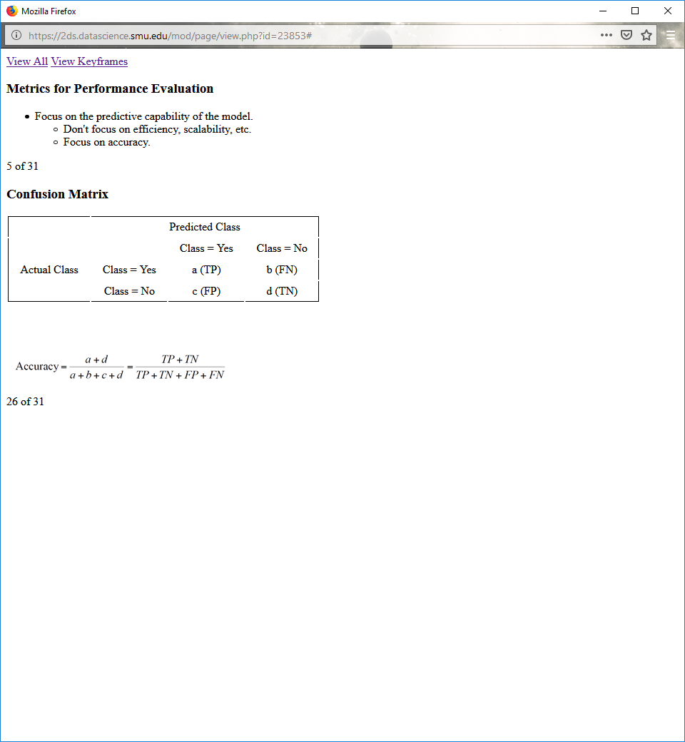

**Limitation of Accuracy**

Accuracy ignores the cost of misclassifications.

Consider an imbalanced 2-class problem.

Number of class 0 examples = 9990

Number of class 1 examples = 10

If model predicts everything to be class 0, accuracy is 9990/10000 = 99.9%.

Accuracy is misleading because model does not detect any class 1 example.

**Cost Matrix**

|  |  |  |  |
| --- | --- | --- | --- |
|  | **Predicted Class** | | |
| **Actual Class** | **C (i|j)** | **Class = Yes** | **Class = No** |
| **Class = Yes** | C (Yes|Yes) | C (No|Yes) |
| **Class = No** | C (Yes|No) | C (No|No) |

Define a cost function based on your expertise with problem:

*C* (*i*|*j*): Cost of misclassifying class *j* example as class *i*

**Cost Matrix Example**

|  |  |  |  |
| --- | --- | --- | --- |
|  | **Predicted Class** | | |
| **Actual Class** | **C (i|j)** | **+** | **-** |
| **+** | -1 | 100 |
| **-** | 1 | 0 |

Lower cost means "better."

Consider, for example, medical diagnostic costs.

**Cost Matrix Example**

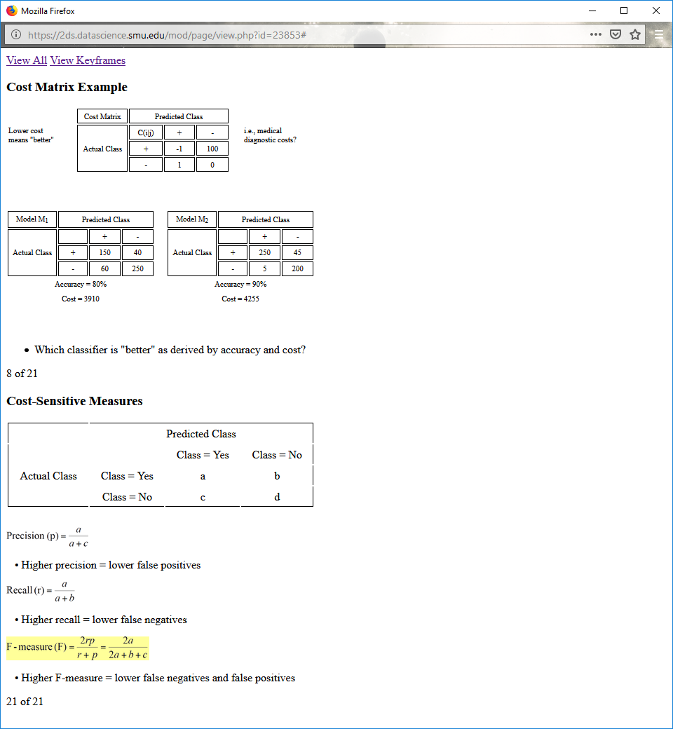



Which classifier is "better" as derived by accuracy and cost?

**Cost-Sensitive Measures**



Precision (p) = $\frac{a}{a+c}$

Higher precision = lower false positives

Recall (r) = $\frac{a}{a+b}$

Higher recall = lower false negatives

F-measure (F) = $\frac{2rp}{r+p}$ = $\frac{2a}{2a+b+c}$

Higher F-measure = lower false negatives and false positives

**7.4**

**Model Evaluation**

How reliable are the estimates of performance?

How many samples of data set are needed for a good classification?

**Learning Curve: Number of Samples**

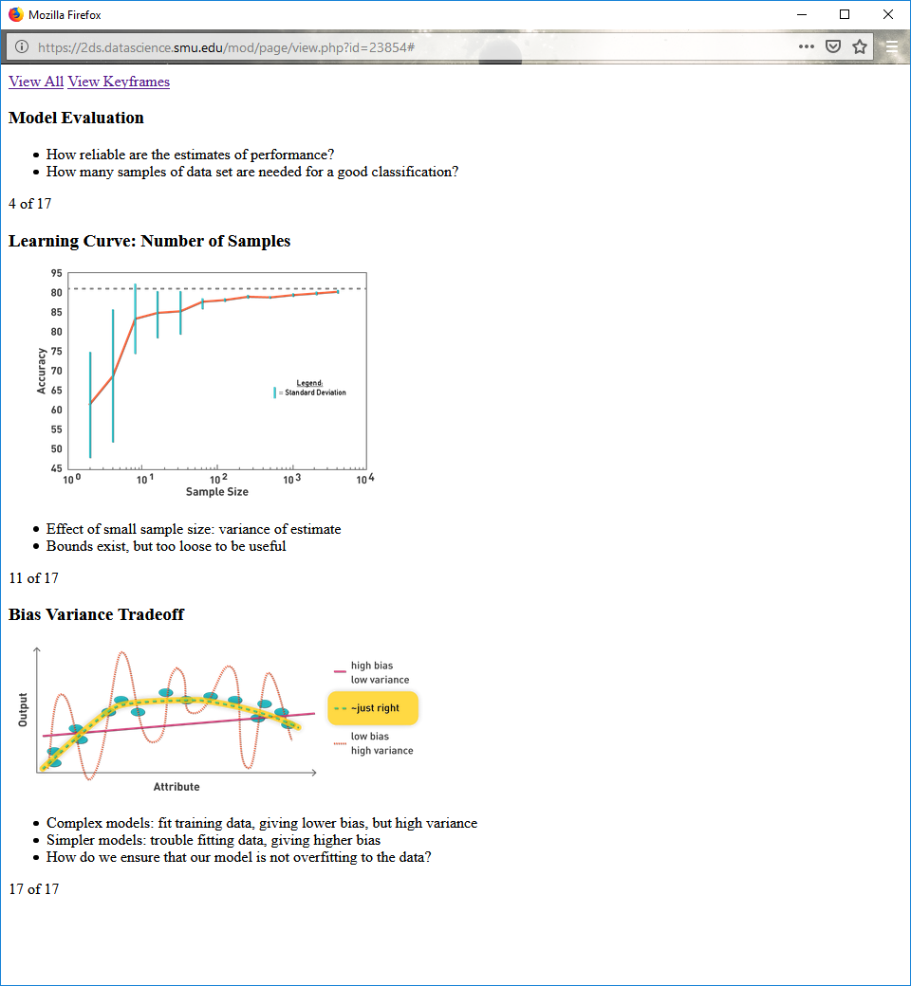

Effect of small sample size: variance of estimate

Bounds exist, but too loose to be useful

**Bias Variance Tradeoff**



Complex models: fit training data, giving lower bias, but high variance

Simpler models: trouble fitting data, giving higher bias

How do we ensure that our model is not overfitting to the data?

**Methods of Estimating Generalization**

Use testing set (and never let the model see it).

Holdout

Reserve 2/3 for training and 1/3 for testing.

Random subsampling

Use repeated holdout, without replacement.

Cross validation

Partition data into k disjoint subsets.

K-fold: train on k-1 partitions, test on the remaining one.

**Stratified Cross Validation**

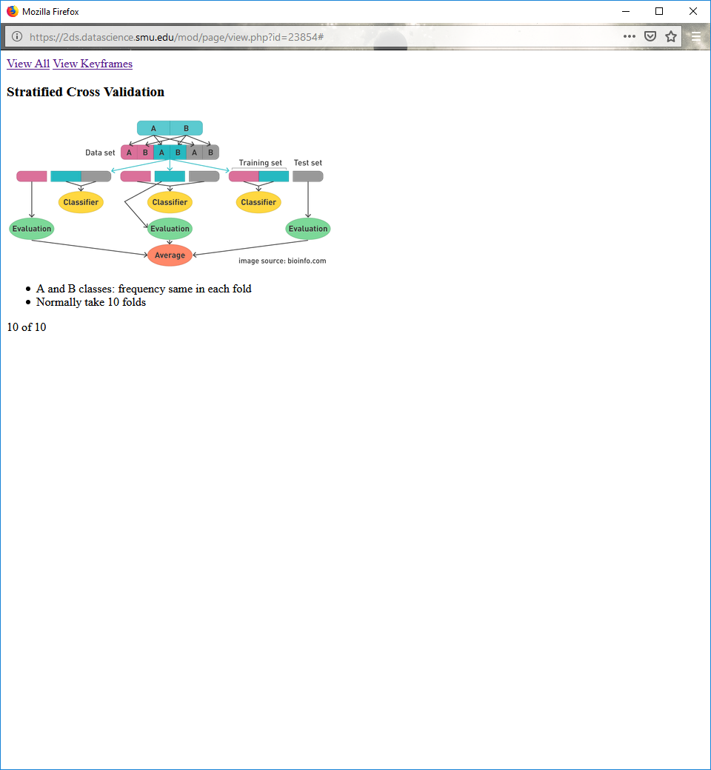

A and B classes: frequency same in each fold

Normally take 10 folds

**Cross Validation**



**Cross Validation (cont.)**

You should never, never, never look at the test data!

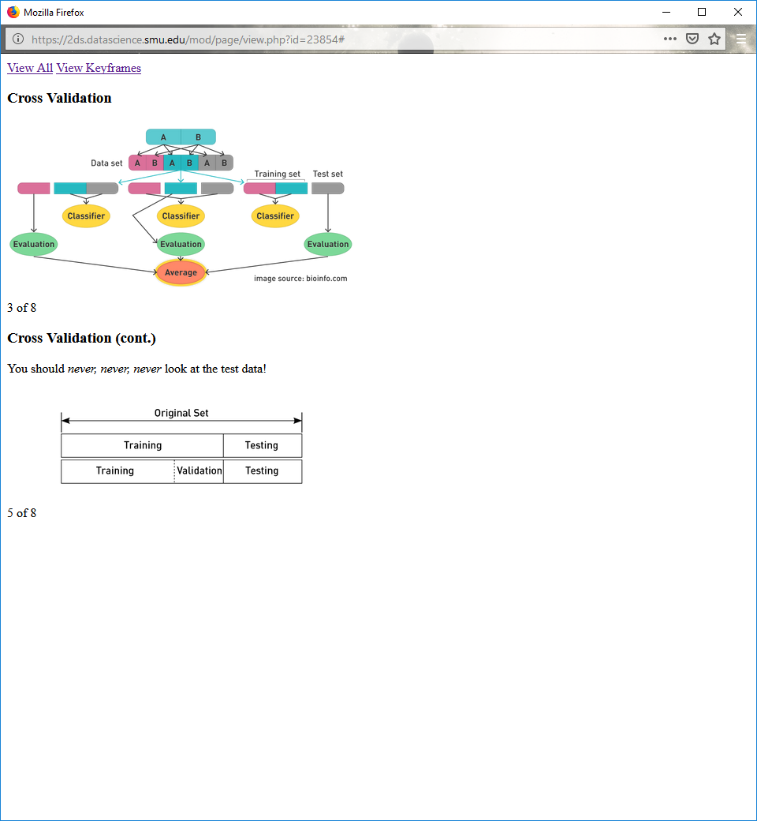

**ROC**

Stands for receiver operating characteristic

Developed in 1950s for signal detection theory to analyze noisy signals

Characterizes the trade-off between positive hits and false alarms

Our interest: threshold related to accuracy of our classifier

**ROC Curve**

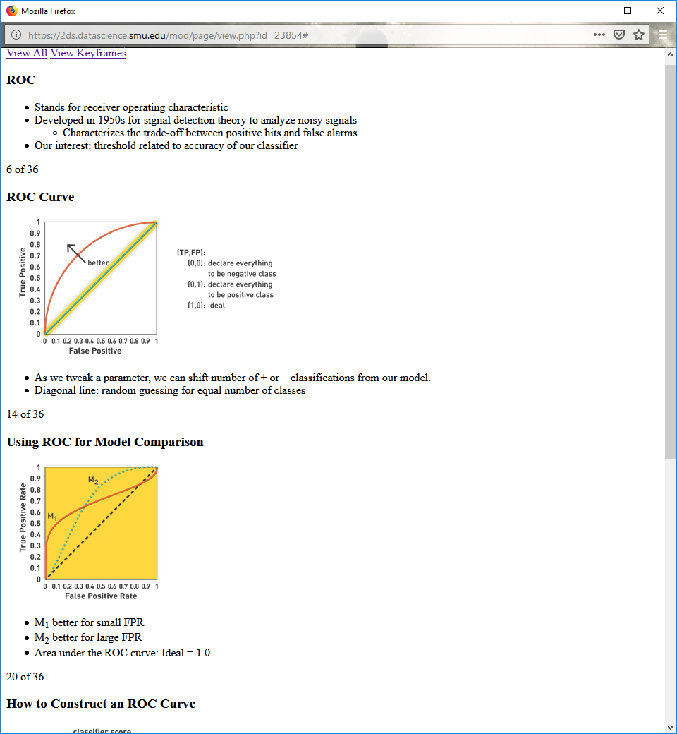

As we tweak a parameter, we can shift number of + or – classifications from our model.

Diagonal line: random guessing for equal number of classes

**Using ROC for Model Comparison**



M1 better for small FPR

M2 better for large FPR

Area under the ROC curve: Ideal = 1.0

**How to Construct an ROC Curve**

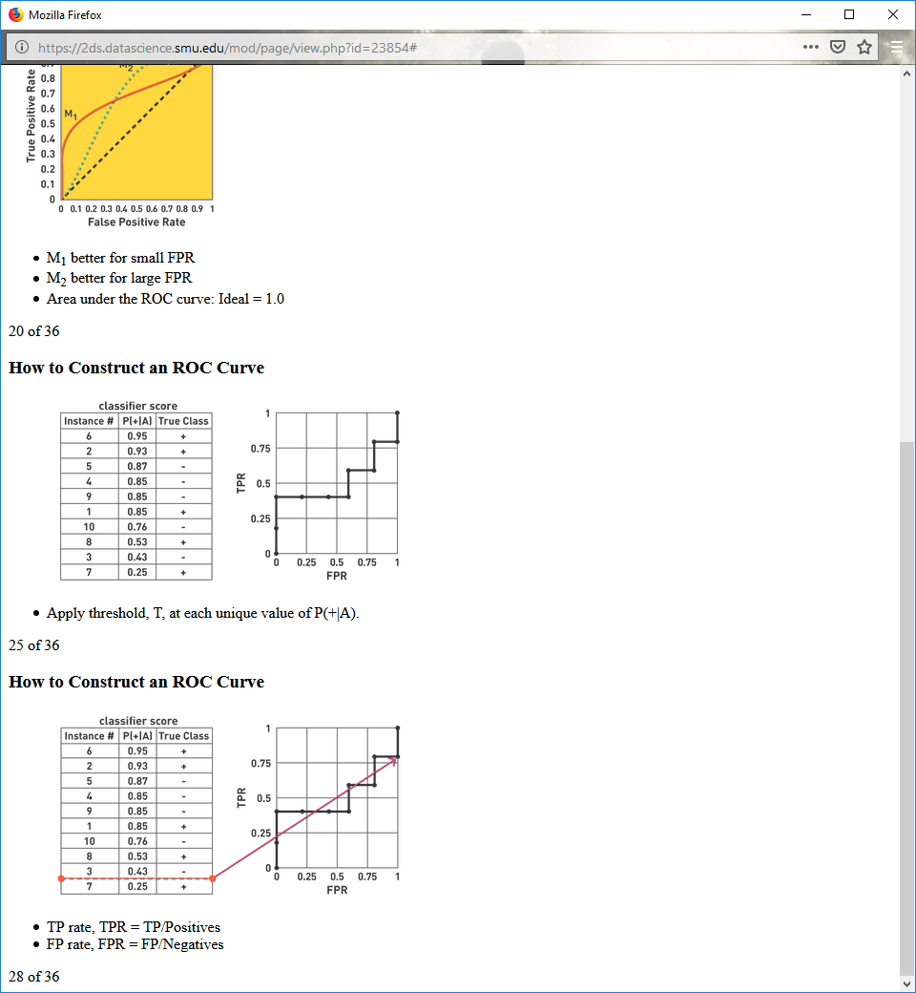

Apply threshold, T, at each unique value of P(+|A).

**How to Construct an ROC Curve**



TP rate, TPR = TP/Positives

FP rate, FPR = FP/Negatives

**7.5**

Approximated the variances with a binomial distribution

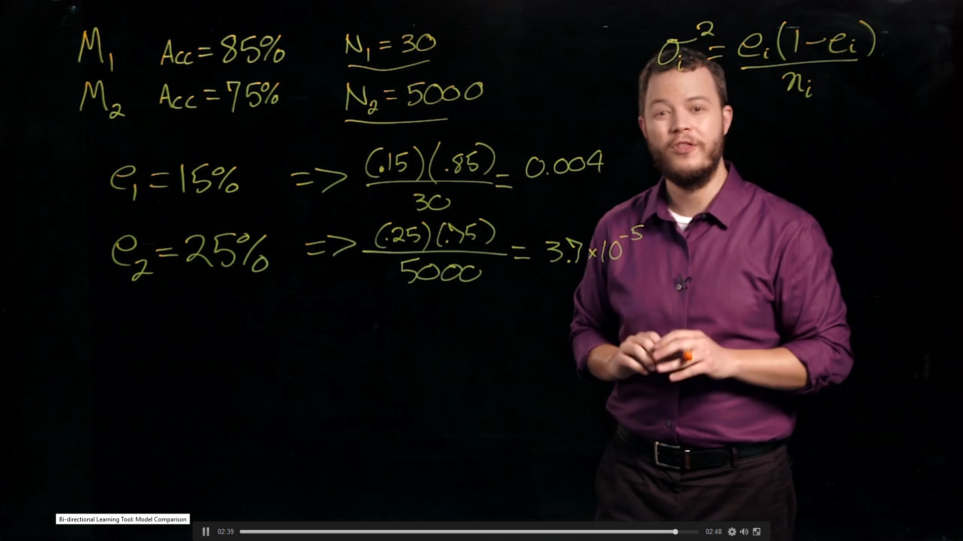

Using a Gaussian distribution

If they are independent of one another it equals another Gaussian distrubtion

How confident are we that they are does or does not include zero (if the mean is zero there really isn’t a difference between the two of them)

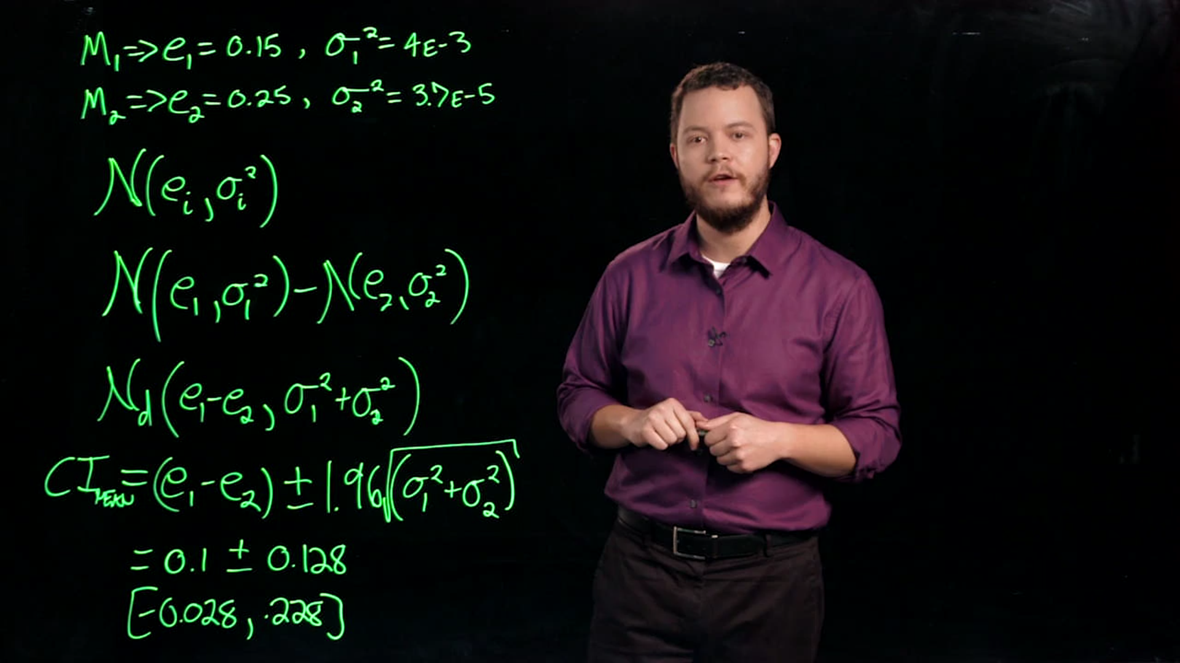

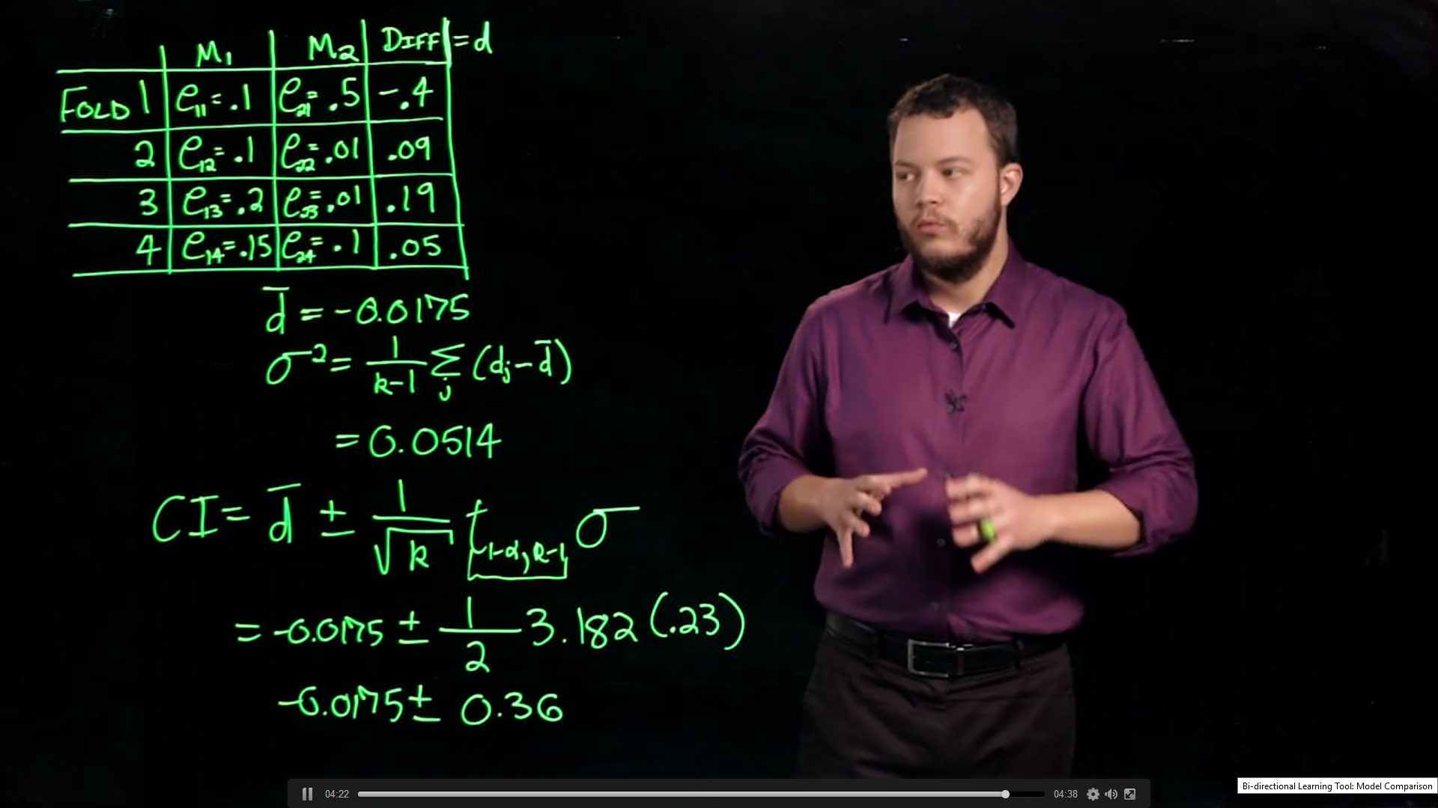

>> means much much greater

When comparing two models we want a+d to be much much greater than c+b

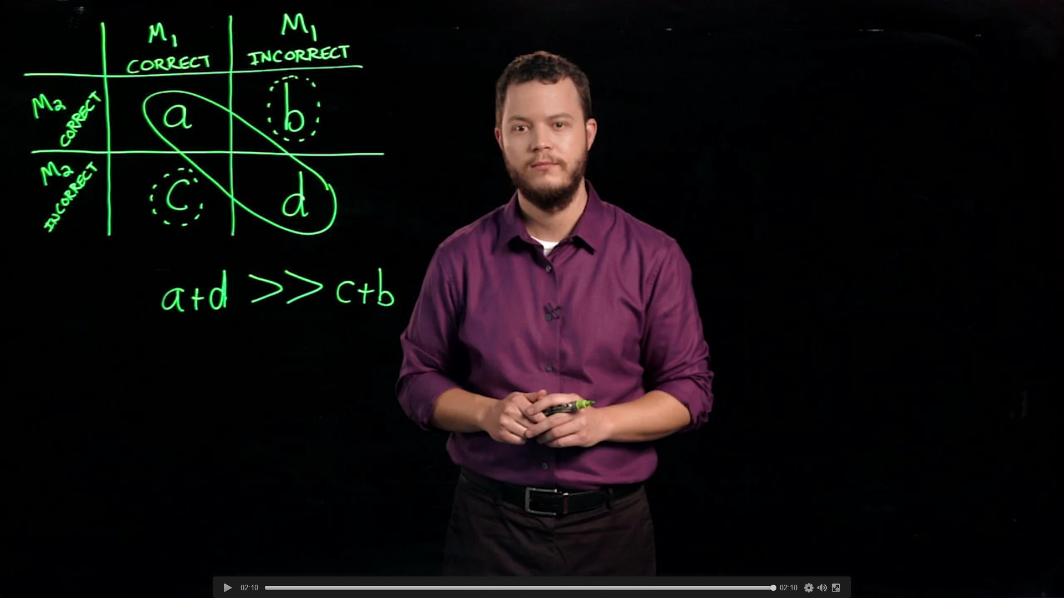

**7.6**

**Ensemble Methods**

Construct a set of classifiers from the training data

Combine outputs of sets together.

Predict class label of previously unseen records.

**General Idea**

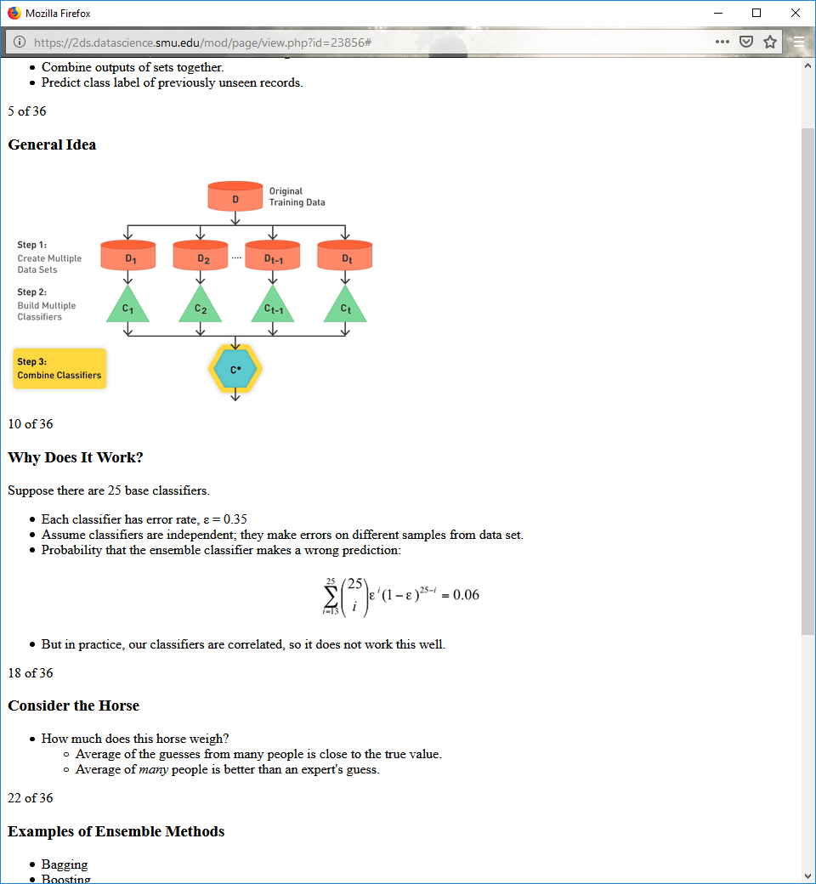

**Why Does It Work?**

Suppose there are 25 base classifiers.

Each classifier has error rate, ε = 0.35

Assume classifiers are independent; they make errors on different samples from data set.

Probability that the ensemble classifier makes a wrong prediction:

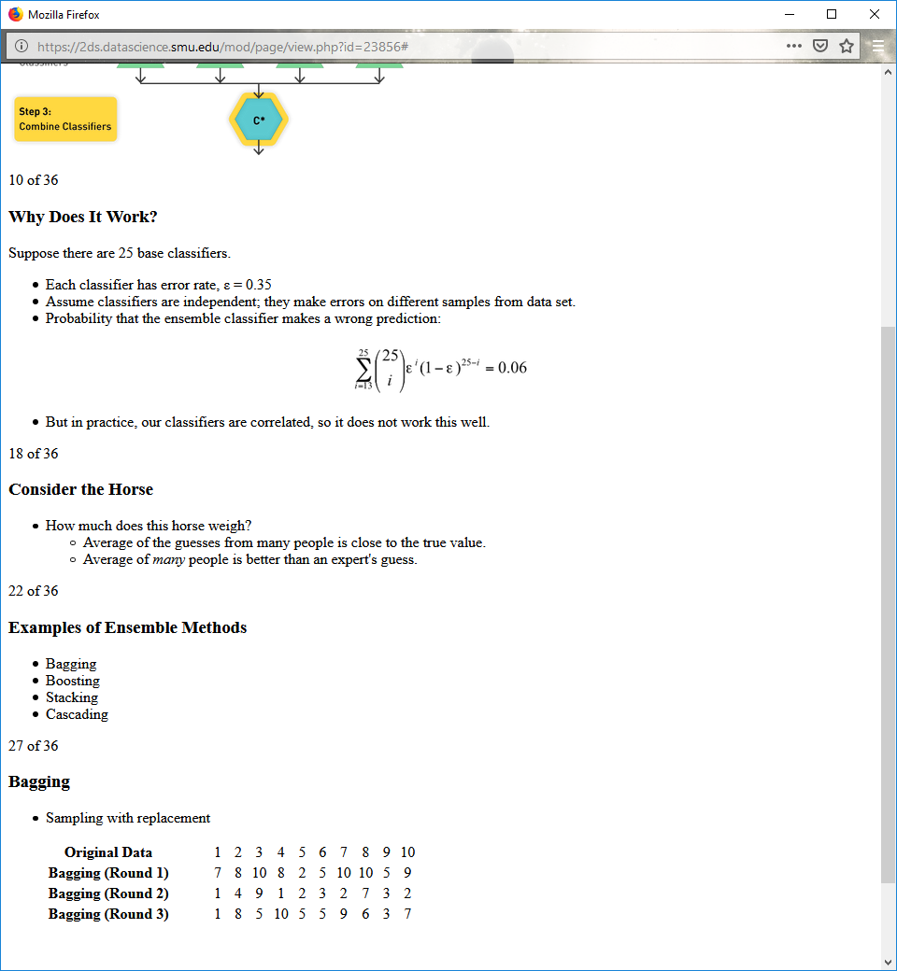

But in practice, our classifiers are correlated, so it does not work this well.

**Consider the Horse**

How much does this horse weigh?

Average of the guesses from many people is close to the true value.

Average of many people is better than an expert's guess.

**Examples of Ensemble Methods**

Bagging

Boosting

Stacking

Cascading

**Bagging**

Sampling with replacement

|  |  |  |  |  |  |  |  |  |  |  |
| --- | --- | --- | --- | --- | --- | --- | --- | --- | --- | --- |
| Bagging | | | | | | | | | | |
| **Original Data** | 1 | 2 | 3 | 4 | 5 | 6 | 7 | 8 | 9 | 10 |
| **Bagging (Round 1)** | 7 | 8 | 10 | 8 | 2 | 5 | 10 | 10 | 5 | 9 |
| **Bagging (Round 2)** | 1 | 4 | 9 | 1 | 2 | 3 | 2 | 7 | 3 | 2 |
| **Bagging (Round 3)** | 1 | 8 | 5 | 10 | 5 | 5 | 9 | 6 | 3 | 7 |

Build classifiers from random subsamples of data.

Take majority vote of the resulting classifiers.

More models is better…like thousands.

May be better to selectively sample hard to classify instances (boosting).

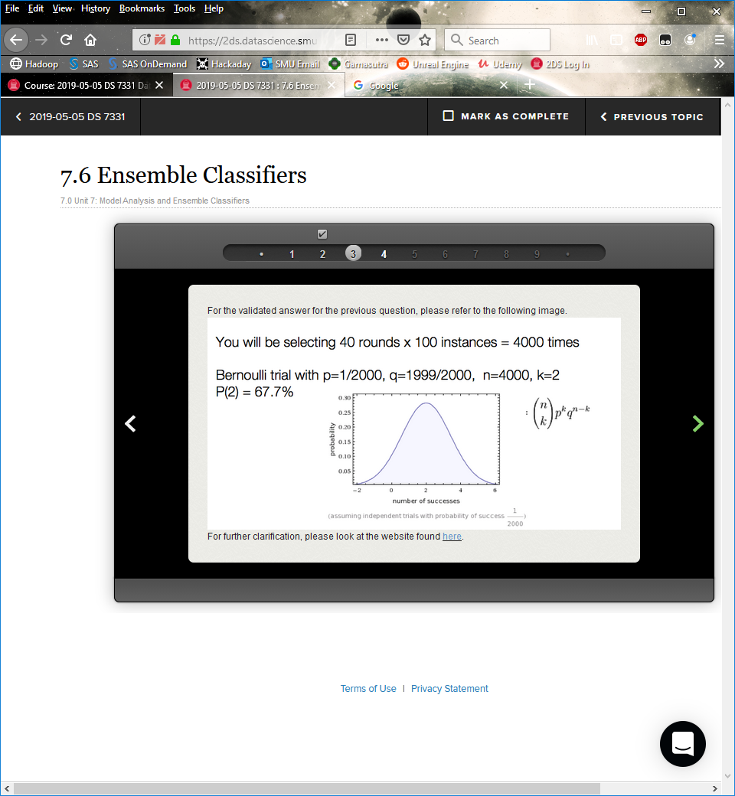

**Boosting and Bagging**

**Weak learner:** a learner with better-than-chance accuracy (error < 50% for two-class problem)

i.e., classifier has high bias

Like a pruned decision tree

**Strong learner:** arbitrarily small error rate

**Boosting**

An iterative procedure to adaptively change distribution of training data by focusing more on previously misclassified record

Initially, all N records are assigned equal weights.

Weights iteratively updated for when an instance is not classified well.

Samples with a higher weight are more likely to be chosen.

**Boosting Example**

|  |  |  |  |  |  |  |  |  |  |  |
| --- | --- | --- | --- | --- | --- | --- | --- | --- | --- | --- |
|  | | | | | | | | | | |
| **Original Data** | 1 | 2 | 3 | 4 | 5 | 6 | 7 | 8 | 9 | 10 |
| **Boosting (Round 1)** | 7 | 3 | 2 | 8 | 7 | 9 | 4 | 10 | 6 | 3 |
| **Boosting (Round 2)** | 5 | 4 | 9 | 4 | 2 | 5 | 1 | 7 | 4 | 2 |
| **Boosting (Round 3)** | 4 | 4 | 8 | 10 | 4 | 5 | 4 | 6 | 3 | 4 |

  Records that are wrongly classified will have their weights increased.

**Example: AdaBoost**

Base classifiers: C1, C2,…, CT

Weighted error rate of Ci is:

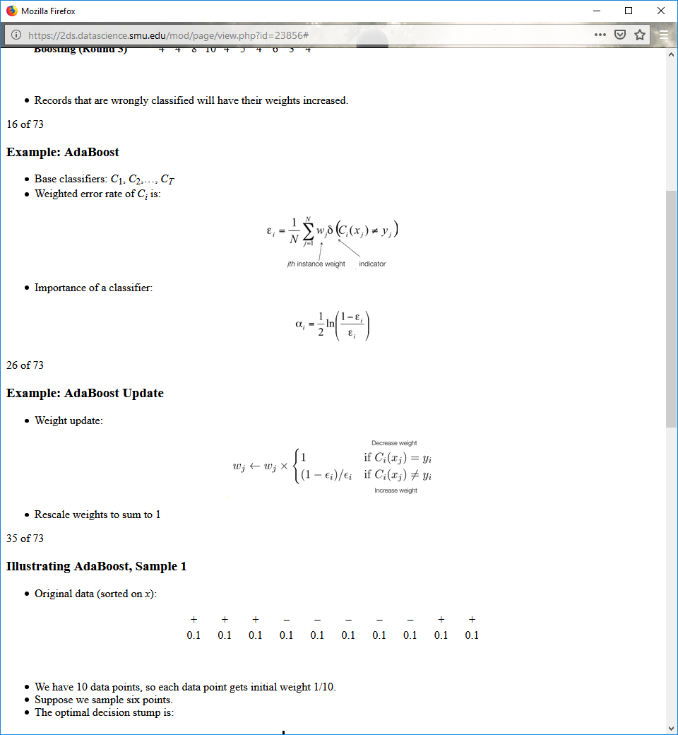 delta function is zero if correct, 1 if incorrect

Importance of a classifier:



**Example: AdaBoost Update**

Weight update:



Rescale weights to sum to 1

**Illustrating AdaBoost, Sample 1**

Original data (sorted on x):

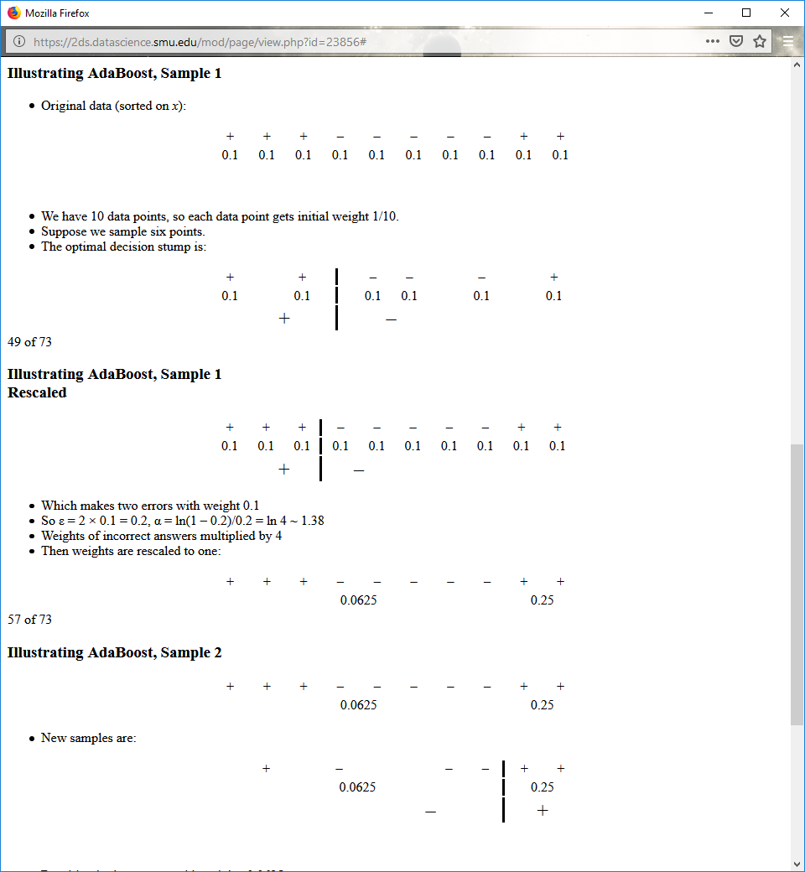

We have 10 data points, so each data point gets initial weight 1/10.

Suppose we sample six points.

The optimal decision stump is:



**Illustrating AdaBoost, Sample 1 Rescaled**



Which makes two errors with weight 0.1

So ε = 2 × 0.1 = 0.2, α = ln(1 – 0.2)/0.2 = ln 4 ~ 1.38

Weights of incorrect answers multiplied by 4

Then weights are rescaled to one:



**Illustrating AdaBoost, Sample 2**



New samples are:



Resulting in three errors with weights 0.0625

So ε = 3 × 0.0625 = 0.1875

α = ln (1 – 0.1875)/0.1875 = ln 4.33 ~ 1.47

**Illustrating AdaBoost, Sample 3**

New weights are:

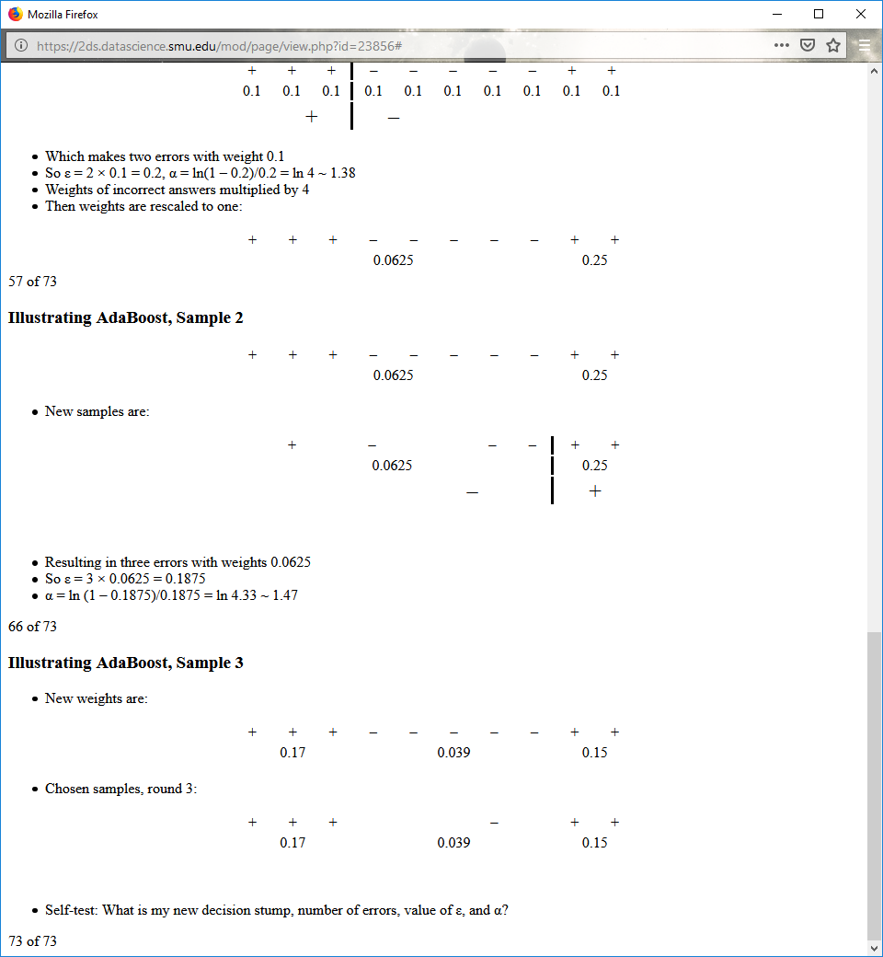

Chosen samples, round 3:



Self-test: What is my new decision stump, number of errors, value of ε, and α?

**Self-Test: Illustrating AdaBoost**

Chosen samples, round three:

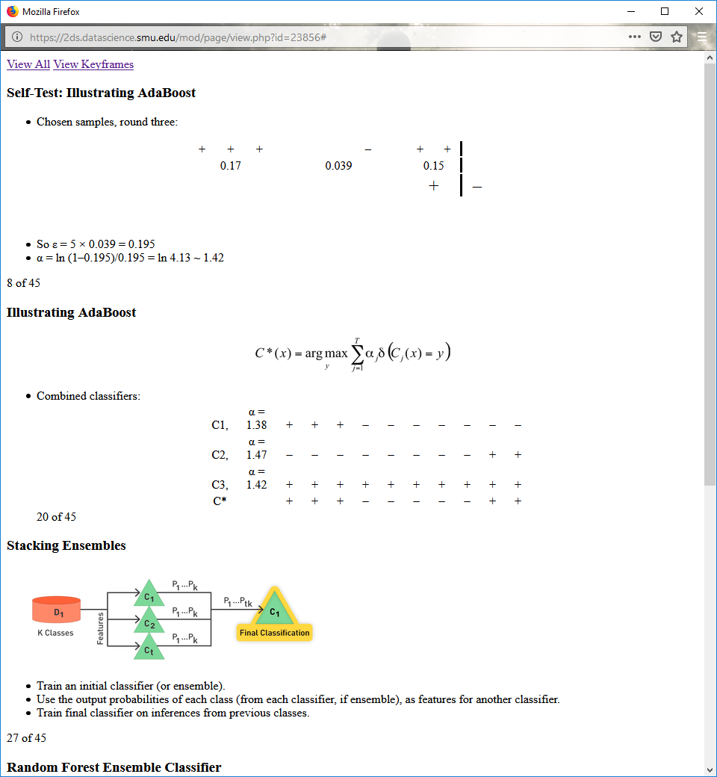

So ε = 5 × 0.039 = 0.195

α = ln (1–0.195)/0.195 = ln 4.13 ~ 1.42

**Illustrating AdaBoost**



Combined classifiers:



**Stacking Ensembles**



Train an initial classifier (or ensemble).

Use the output probabilities of each class (from each classifier, if ensemble), as features for another classifier.

Train final classifier on inferences from previous classes.

**Random Forest Ensemble Classifier**

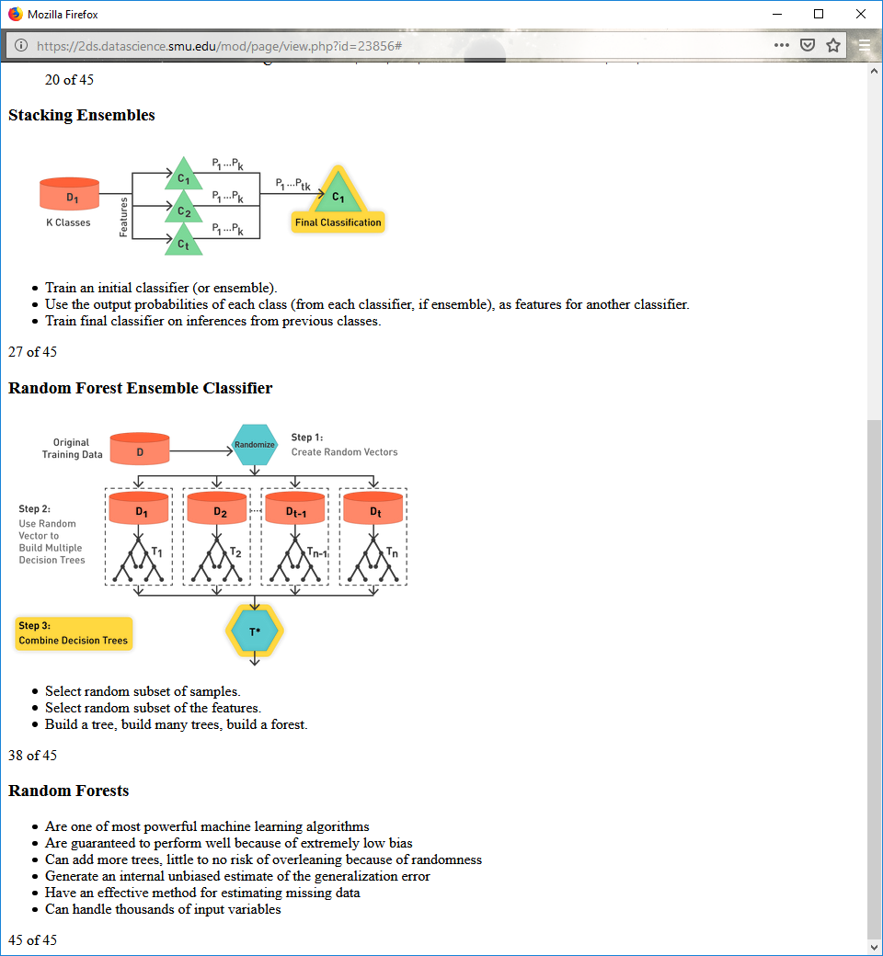

Select random subset of samples.

Select random subset of the features.

Build a tree, build many trees, build a forest.

**Random Forests**

Are one of most powerful machine learning algorithms

Are guaranteed to perform well because of extremely low bias

Can add more trees, little to no risk of overlearning because of randomness

Generate an internal unbiased estimate of the generalization error

Have an effective method for estimating missing data

Can handle thousands of input variables